The ATV Safety Institute's Golden Rules

- Always wear a DOT-compliant helmet, goggles, long sleeves, long pants, over-the-ankle boots, and gloves
- Never ride on paved roads except to cross when done safely and permitted by law - another vehicle could hit you, ATVs are designed to be operated off-highway
- Never ride under the influence of alcohol or drugs
- Never carry a passenger on a single-rider ATV, and no more than one passenger on an ATV specifically designed for two people
- Ride an ATV that's right for your age
- Supervise rider’s younger than 16; ATVs are not toys
- Ride only on designated trails and at a safe speed
- T-CLOC Pre-Ride Inspection Checklist

Classes are being held throughout New Mexico
Call 575-840-9555
to join a class
in your area or make a reservation.
Curtis W. Thomas
(ASI) ATV Safety Institute Representative
of New Mexico

Classes held on Saturday or Sunday unless a group or organization is wanting the training durining the weekday

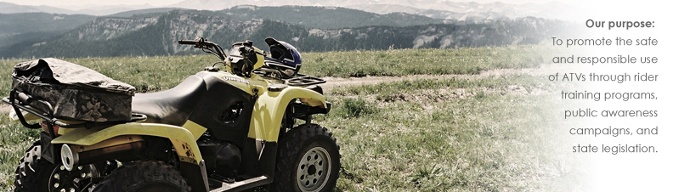
For nearly all outdoor activities, proper equipment and clothing add to the experience. Skiers wear apparel designed for protection against the elements, flexibility of movement and style. Fly fishers wear waterproof boots and waders to give them freedom to move into a stream. Each activity has its own special requirements. ATV riding is no different.
ATV riding requires protection for head, eyes, hands and feet against occasional spills, flying debris, or contact with foliage. The same gear makes riding more comfortable with less fatigue. For the minimum comfort and protection, check out the Working Rider. For the ultimate in style and protection, check out the Recreational Rider.
Respect the Outdoors
Awareness of environmental concerns has been growing for decades. It has affected how we relate to the outdoors. It affects those of us who use off-road vehicles, and it affects those of us who manufacture and sell off-road vehicles. We all have a stake in safe, responsible riding and land use.
To keep riding areas open requires good relationships between public land managers, private land owners and others who share the land such as riders, campers and hikers. In most cases common courtesy and consideration of their interests is all that is necessary to ensure that everyone can enjoy the area. Here are some tips to consider when you ride:
- Learn about the area you will ride in. Contact the public land manager or private property owner to ensure that you understand area restrictions and have permission to ride there. Get maps of the area, and stay on trails if they are provided.
- Keep your ATV quiet. ATVs are designed to be relatively quiet while still delivering maximum performance, smooth engine torque and spark suppression. Excessive noise stresses wildlife, and annoys property owners and other recreation users. It also contributes to your own riding fatigue. Less noise means you can ride farther more comfortably.
- Obey trail markers and closure signs. There are many reasons why an area may be closed to ATVs including the existence of fire hazard, refuge to wildlife or plant life and safety hazards for ATV riders. The reasons may not be obvious. If it is posted as closed, stay out.
- Always leave gates and fences the way you found them. This is especially important on private lands where livestock may be kept.
- Leave the area as clean as you found it. If you see litter, pick it up and carry it out on your ATV. Carry a rolled-up plastic trash bag and a couple of bungee cords on your ATV. Why not leave the area cleaner than you found it?
- Be courteous to others you may meet on the trail. Always give right-of-way to hikers and horseback riders. Pull off the trail and stop your engine for horses. In most areas, horses are not permitted on trails unless they are accustomed to vehicles, but don't take a chance. The rider will likely talk soothingly to the horse. It doesn't hurt for you to do the same to assure the horse you are no threat. Horses respond very positively to a calm, human voice.
- Approach livestock or wildlife on the trail slowly. In some parts of the country, range cattle pass the afternoon under shade trees along a trail. If you startle them, they may run directly into your path. Give them time to react and give them as wide a berth as possible.
- Whenever you talk to a landowner, take your helmet off. The helmet can make you appear to be intimidating and unfriendly. Be friendly and honest in all your discussions with the landowner & you are there as their guest.

