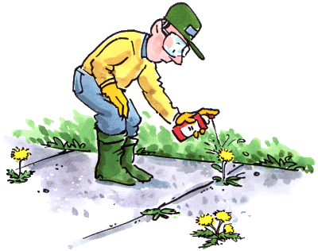

575-840-9555
Email: trainitnm@gmail.com
trainitnm.com

TRAIN IT NEW MEXICO
Vegetation Management Training

- Classroom and Hands on Demonstration
- All Training Material Provided
- Weed Identification Publication Issued
- Laws and Regulation Explained
- Learning How to Keep Proper Records
- Understanding Chemicals and How to Use Them, Bare Ground
- Calibration Demonstrated with Backpack and Boom Sprayer
- Class will be held in Your Town

