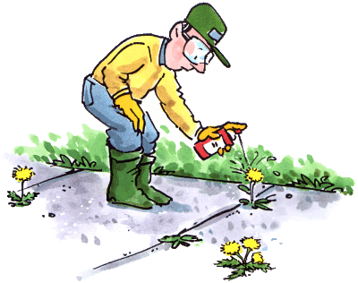

575-840-9555

Email: [trainitnm@gmail.com](mailto:trainitnm@gmail.com)

trainitnm.com

**TRAIN IT NEW MEXICO**

Vegetation Management Training

* Classroom and Hands on Demonstration
* All Training Material Provided
* Weed Identification Publication Issued
* Laws and Regulation Explained
* Learning How to Keep Proper Records
* Understanding Chemicals and How to Use Them, Bare Ground
* Calibration Demonstrated with Backpack and Boom Sprayer
* Class will be held in Your Town